**Introduction to Human Computer Interaction**

**Assignment No. 2**

****

**Session: 2021**

**Submitted by:**

**Wali Muhammad 2021-SE-39**

**Submitted to:**

**Sir Umar Qasim**

**Assignment Title**

**Protocol Analysis**

**[Department of Computer Science]**

**University of Engineering and Technology (New Campus),**

**Lahore.**

**Protocol Analysis Report**

**Website Introduction**

[The University of Engineering and Technology, Lahore is a public university located in Lahore, Punjab, Pakistan specializing in science, technology, engineering and mathematics subjects. It is the oldest institute of engineering in Lahore. This is the Official website of The University of Engineering and Technology. This website is used for many purposes such as apply online admissions in UET, See Merit Lists and Other admission related details and administration purposes.](https://www.bing.com/ck/a?!&&p=3f438d0d014d419cJmltdHM9MTY3MTQwODAwMCZpZ3VpZD0yYjg4NzM4MC04NTk4LTY1N2ItMWQ5Mi02MWU4ODQ4YzY0ZjgmaW5zaWQ9NTU2Mg&ptn=3&hsh=3&fclid=2b887380-8598-657b-1d92-61e8848c64f8&psq=uet.edu.pk&u=a1aHR0cHM6Ly9lbi53aWtpcGVkaWEub3JnL3dpa2kvVW5pdmVyc2l0eV9vZl9FbmdpbmVlcmluZ19hbmRfVGVjaG5vbG9neSxfTGFob3Jl&ntb=1" \o "en.wikipedia.org" \t "_blank)

**Website Link**

The website link is provided below:

## [UET Lahore | University of Engineering and Technology](https://www.bing.com/ck/a?!&&p=64e98c2c7596d200JmltdHM9MTY3MTQwODAwMCZpZ3VpZD0yYjg4NzM4MC04NTk4LTY1N2ItMWQ5Mi02MWU4ODQ4YzY0ZjgmaW5zaWQ9NTE3OA&ptn=3&hsh=3&fclid=2b887380-8598-657b-1d92-61e8848c64f8&psq=university+of+engineering+and+technology%2c+lahore&u=a1aHR0cHM6Ly93d3cudWV0LmVkdS5way8&ntb=1)

https://www.uet.edu.pk

**Website Pictures**

**Homepage**

**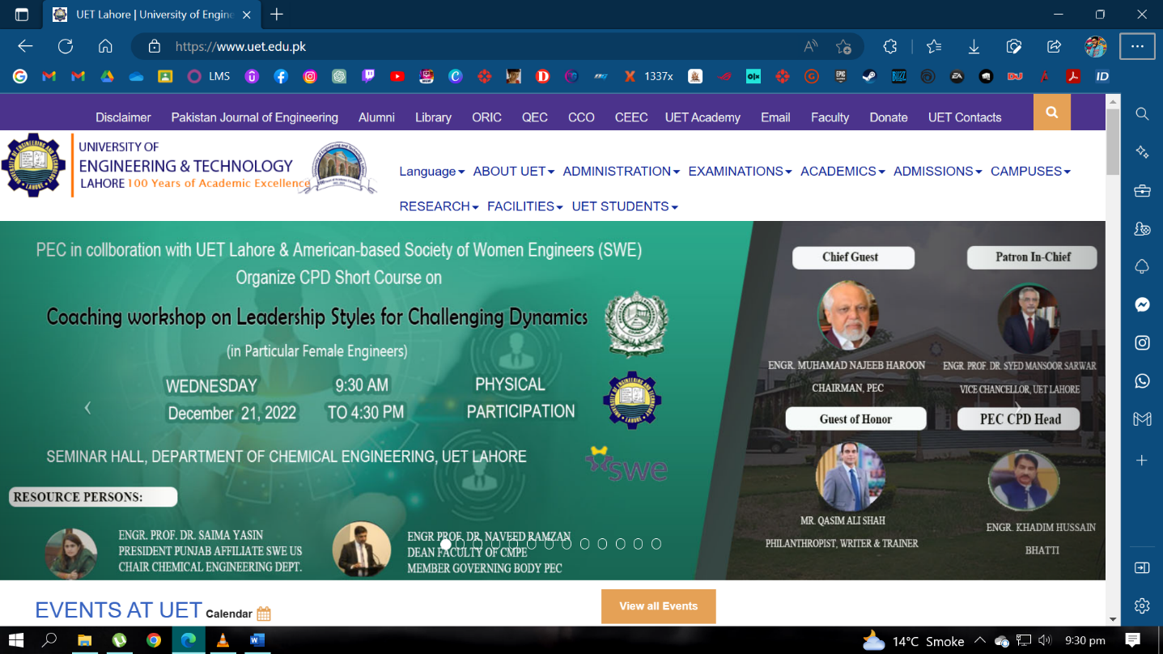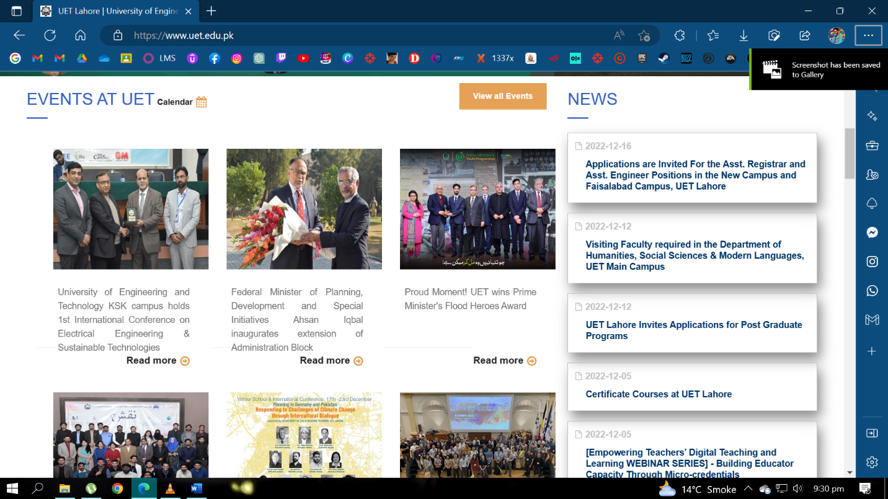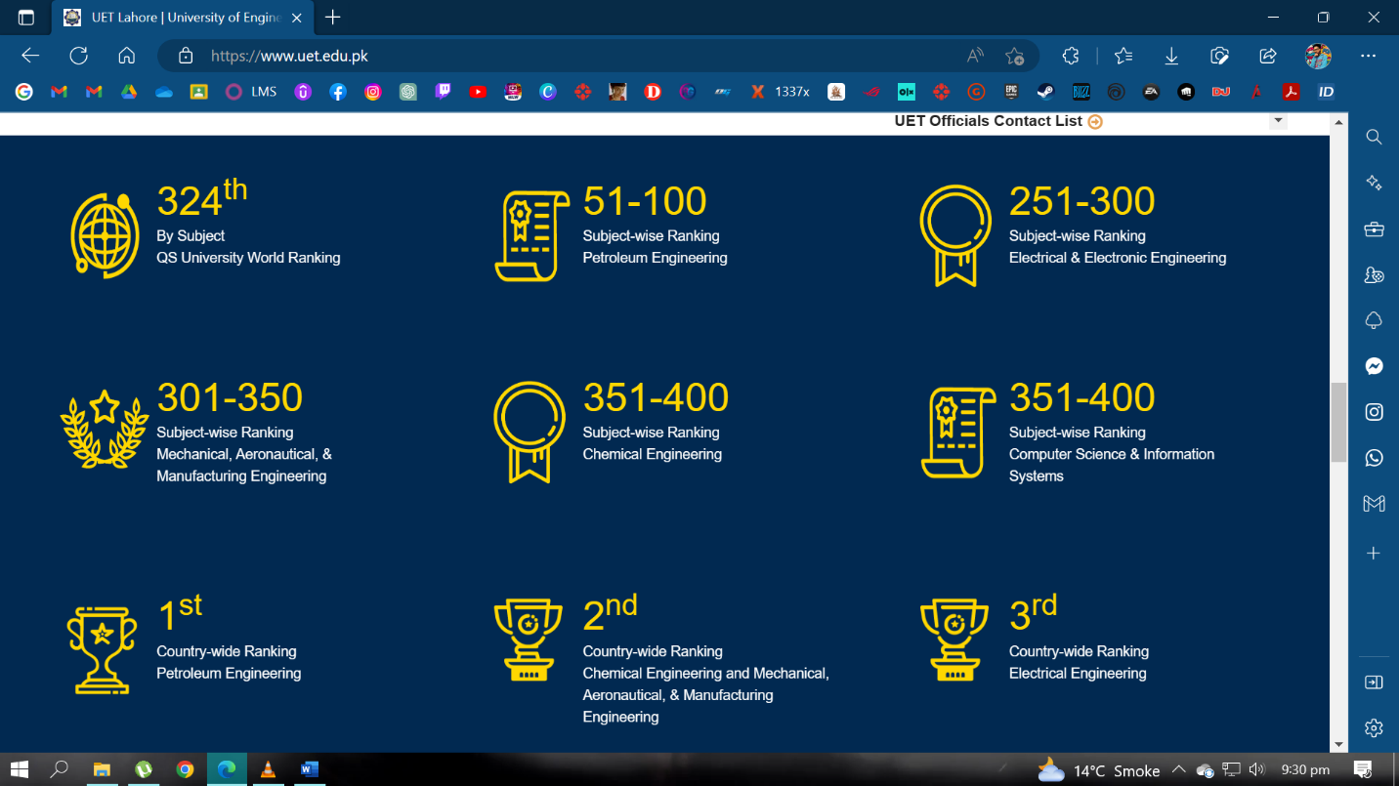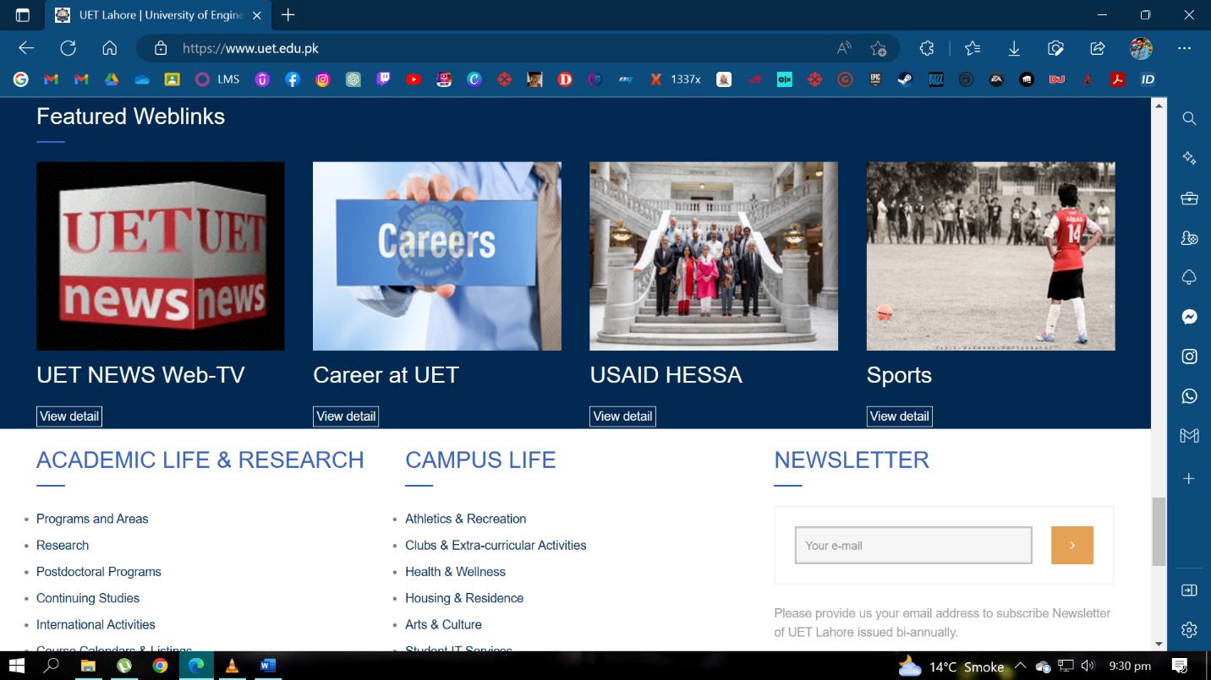**

**Navbar > UET STUDENT**

**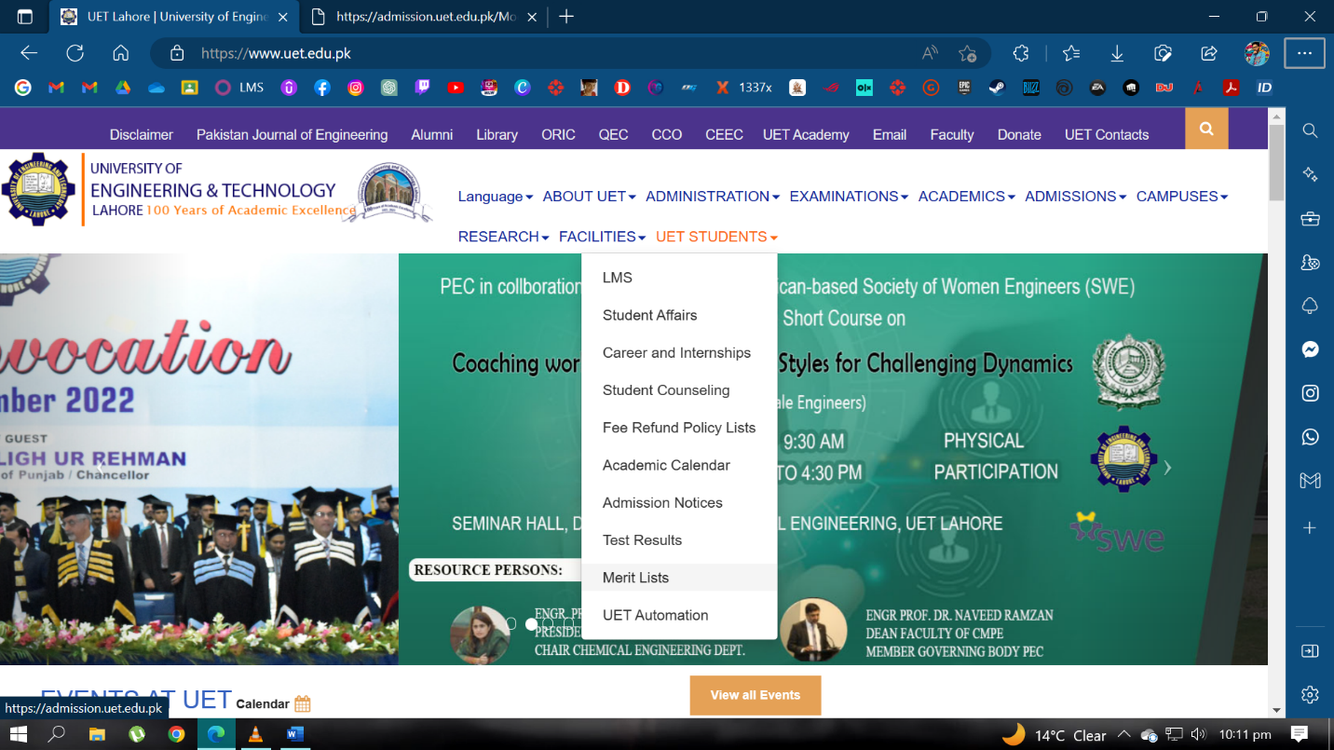**

**UET Admission Portal**

**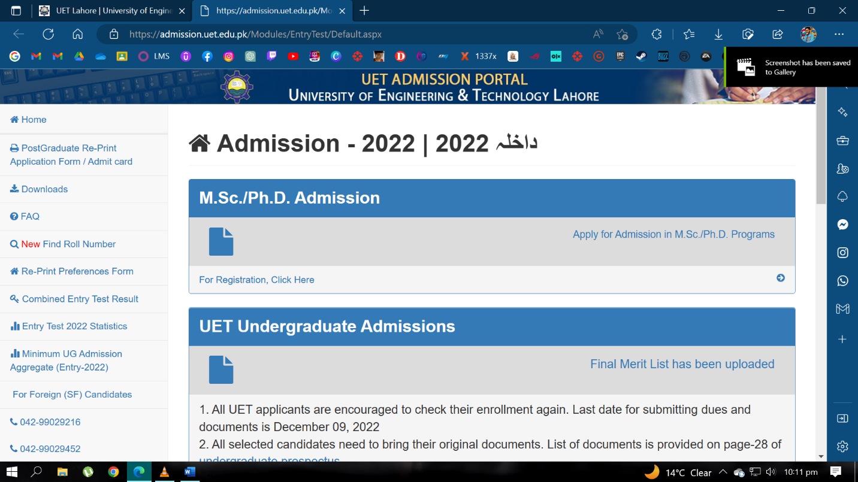**

**Aggregate Page**

**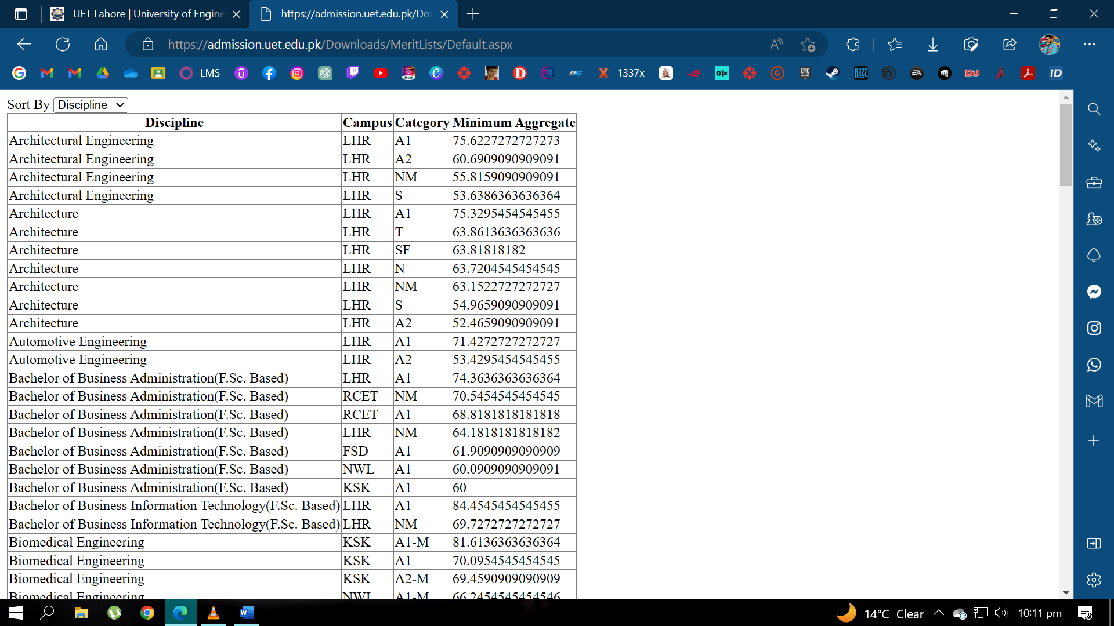**

**Navbar > Campuses Page**

**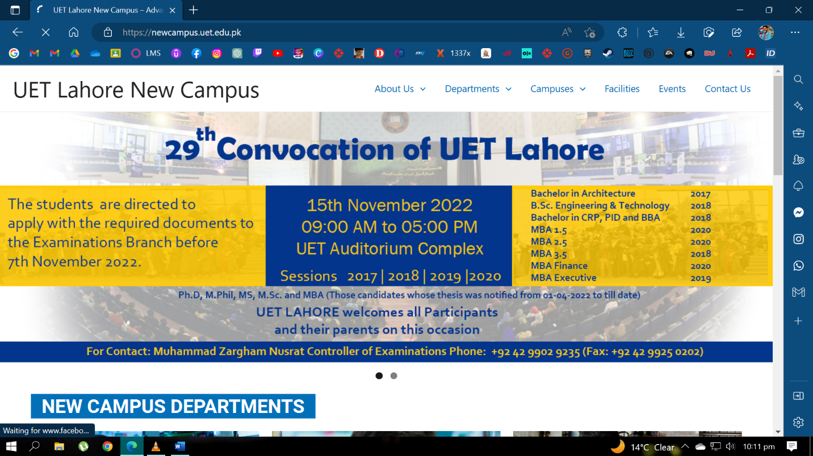**

**KSK Campus Page**

**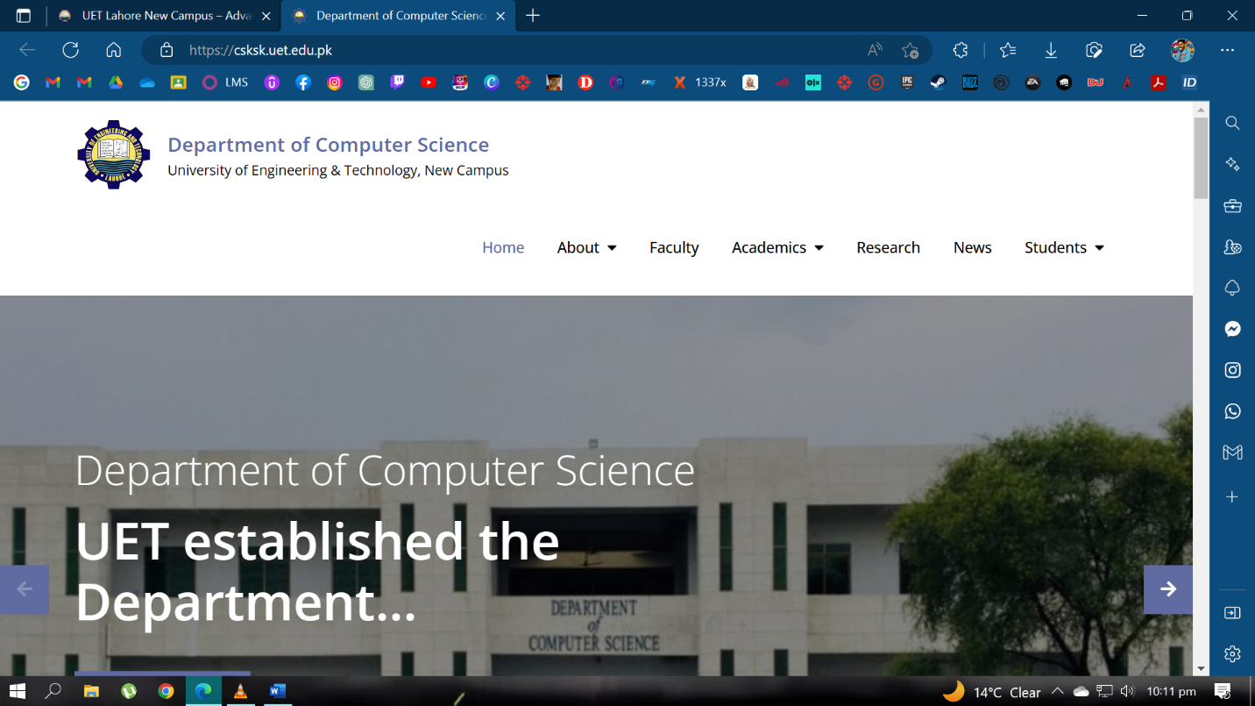**

**BS Software Engineering Page**

**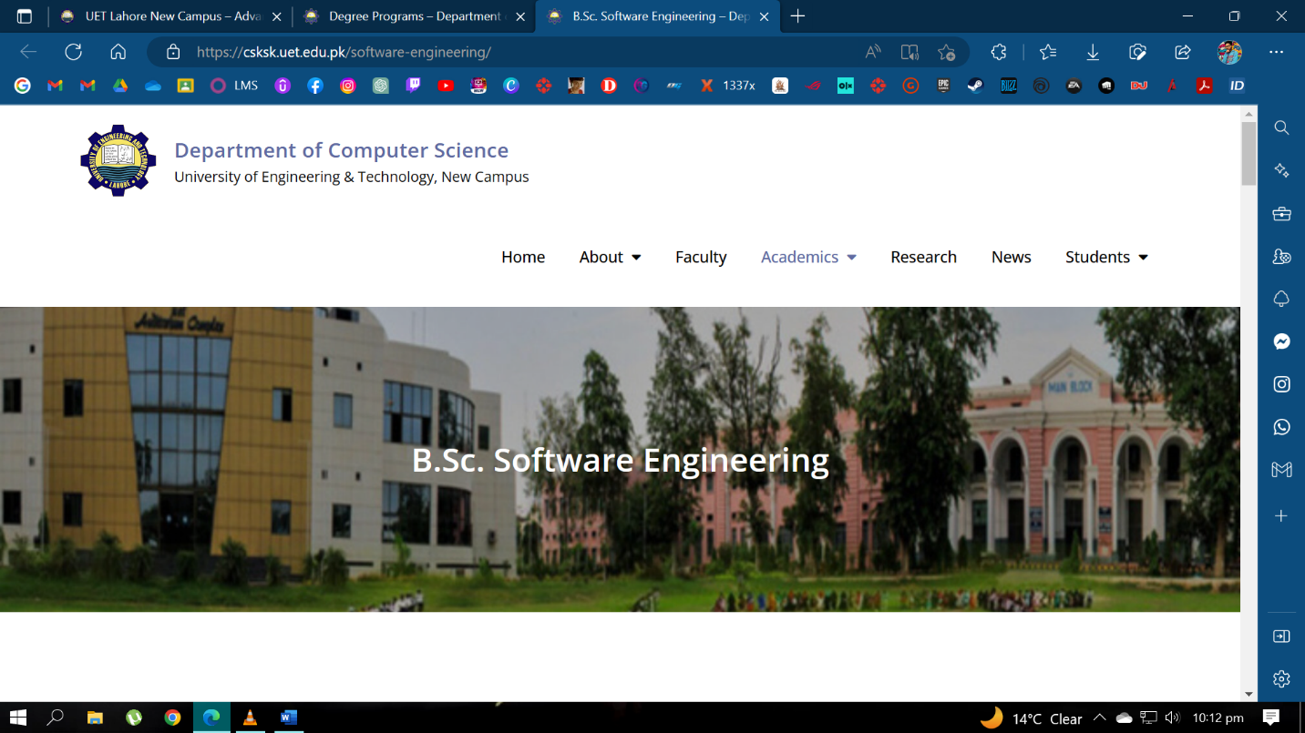**

**Learn More Page > Semester Plan**

**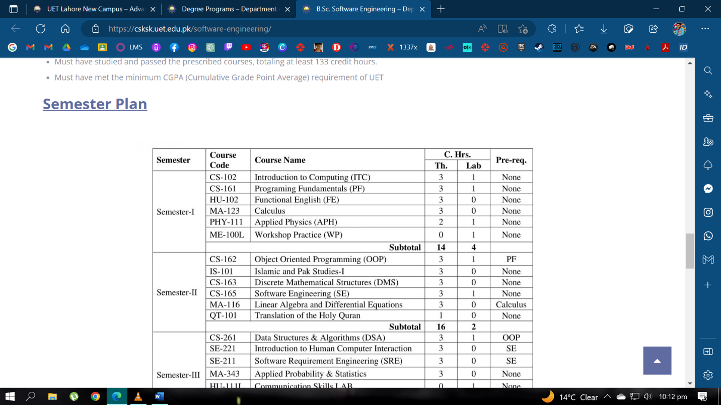**

**Protocol Analysis Tasks**

**Task 1**

**Description**

Check the Merit list of BScs. Software Engineering year 2022 in UET through uet.edu.pk. online website.

* Task 1 is performed by 5 Subjects. Their recorded videos and Observation Process Task Written on pages Images is provided in the Zip file.

**Task 2**

**Description**

See the Semester plan of BSc. Software Engineering year 2022 through uet.edu.pk. online website.

* Task 1 is performed by 5 Subjects. Their recorded videos and Observation Process Task Written on pages Images is provided in the Zip file.

**Protocol Analysis Questionnaire**

Questionnaire have Introduction of the assignment and Task introduction section. User information is also asked in

There are 8 Questions asked in the Questionnaire and it is asked in the form given by:

O Strongly Satisfied O Satisfied O Natural O Dissatisfied O Strongly Dissatisfied

At the end of each Questionnaire feedback is asked by the user for the individual task performed.

**Note**: The Questionnaire are filled by individually from the subjects. Their report and images are provided in Zip-file.

**Problem faced by Subjects/Users**

Problem faced by Subjects/Users in performed tasks and their possible solutions are provided in the table below:

|  |  |
| --- | --- |
| **Problem** | **Solution** |
| * Search bar provided on Homepage is not working. | * Search bar provided on Homepage should work properly and it should be visible. |
| * Too much irrelevant information is provided on Homepage. | * Only the important and latest information should be provided on Homepage and it should be well arranged and clean. |
| * Too many options in Navbar. | * Navbar options should be lesser. Only most used and important option should be provided |
| * User visited many pages and links while doing the task manually. | * The number of pages and clicked button should be less as possible. |
| * No search bar provided on other pages. | * A working search bar should be provided on other pages. |
| * Very biased overall interface of website. | * Website interface should be user-friendly. |

**Conclusion**

In conclusion, this technique is very useful in finding out difficulties performing a task by a user on a website or system. It’s quite effective technique in finding out the errors on the specific tasks performed by a user.

THE END